SPE-GCS Nexonia How-To

Revision No. | Revision Date | Revised By | Function
1 | 19-Feb-2020 | Brian Sinosic | SPE-GCS Treasurer

SPEGCS treasury team: primary responsibilities

Treasurer
  - Annual SPEGCS budget consolidation, monthly budget review and BOD presentation
  - Maintenance of SPEGCS current cash accounts and SPEGCS investment accounts
  - Maintenance and funding of SPEGCS SEF investment accounts
  - Facilitation of payment request reconciliation and authorization of payments

Vice-Treasurer
  - Review and approval of SPEGCS group payment requests
  - Coordination with group Treasurers regarding payment request issues
  - Payment authorization

Section Specialist
  - Maintenance of SPEGCS financial records
  - Coordination of sponsorship receipts/billing
  - Preparation of all payment requests
  - As-arranged support of group events

Study Group/Committee/Event Treasurers
  - Reconciliation of all group receipts and invoices
  - Submission of all group payment requests via Nexonia
  - As-needed coordination with SPEGCS staff regarding event-related major expense direct-billing (venue, catering, etc.)
  - Annual preparation and submission of group budget.

overview

General Payment/Reimbursement Process & Requirements

SPEGCS Payment/Reimbursement Overview
- Nexonia has been adopted as the platform for request and approval of all SPEGCS payments (expense reimbursements, vendor payments, donations, scholarships, etc.)
- Each Study Group/Committee/Event has been allocated one Nexonia account (generally assigned to the group Treasurer). Account changes and password resets are managed by SPEGCS staff.
- Process
  - Group Treasurers submit payment requests through Nexonia
  - Payment requests are reviewed and either approved or rejected:
    - If rejected, requests are returned to the submitter with directions for correction and resubmission.
    - If approved, requests are sent for payment.
  - Payments processed.
    - Event registration refunds: returned to the credit card used for payment
    - Miscellaneous expense reimbursements: check issued to payee. Payment authorization occurs NLT 1/mo (BOD Mtg) or as coordinated in advance.
    - Other: as coordinated with Treasury Team in advance.

Submission Requirements
- All payment requests must correspond to a documented event or allocation within the group’s approved annual budget.
  - Expenditures falling outside of an approved budget require interim approval from the Board of Directors and are subjection to rejection otherwise.
- SPEGCS is a registered 501c (Nor-For-Profit) organization and is therefore exempt from Sales Tax charges. Group Treasurers are responsible for arranging appropriate Sales Tax exemptions with their respective vendors. Reimbursements are subject to removal of Sales Tax charges if significant.
- Expense reimbursements require documented proof of purchase (detailed receipt or invoice, etc.) in addition to payee name and mailing address.
- Non-reimbursement payments (Scholarships, Donations, etc.) also require Nexonia submission, including confirmation of budget approval and payee details.

Nexonia How-To:

Add a Report
- Log in to https://system.nexonia.com/assistant/signin.
    - Alternately, the Nexonia mobile app can be downloaded and used.
- Click Add Report.
    - Select the appropriate Group under Employee
    - Add an appropriately descriptive title. If the report relates to a Group event, a direct copy/paste of the event title as listed in the spegcs.org calendar is ideal.
    - When complete, click Save.
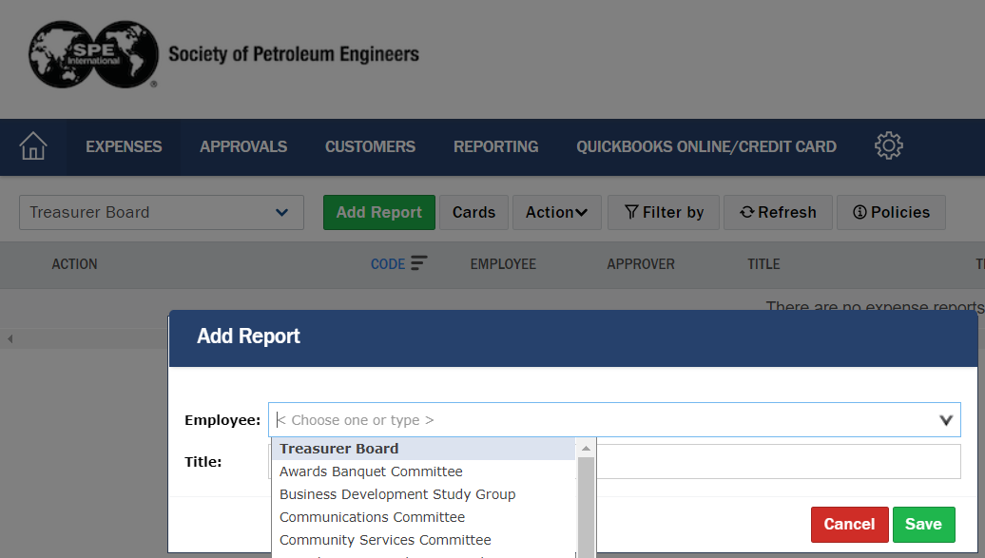
    - The report will be saved with a unique Code number that can be used in any needed follow up.
    - Nexonia reports are intended to be payee-specific. If a payee is being reimbursed for more than one expense, these can be included as multiple expense items within the same report. Existing reports can be duplicated, reducing the data entry requirement if more than one payee requires reimbursement.

- Click Add Expense Item.
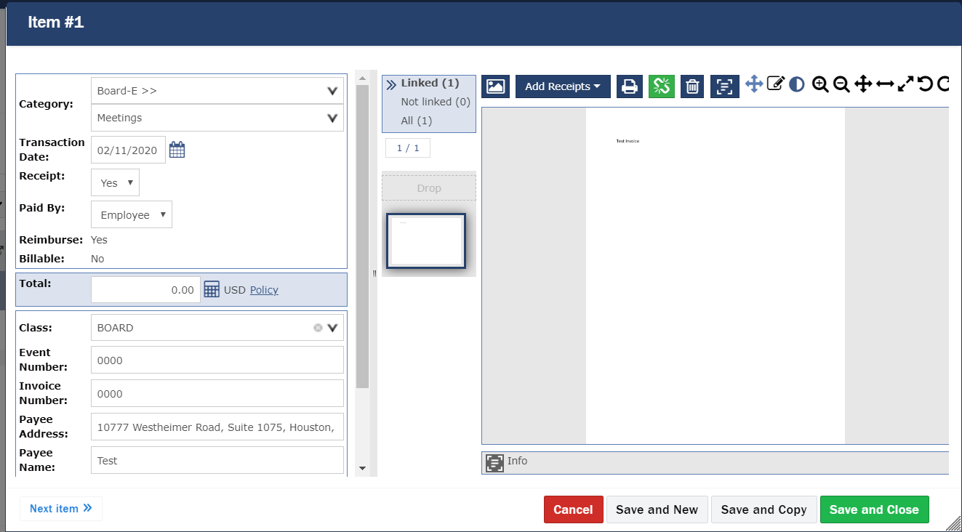
    - Select the appropriate Category. Once selected, choose the appropriate Type.
    - Ensure Transaction Date reflects the date the charge was incurred.
    - Receipt = Yes, Paid By = Employee
    - Ensure Total amount matches supporting documentation/receipts
    - Select the appropriate Class
    - If related to an event, ensure Event Number matches that in the spegcs.org calendar.
    - If applicable, ensure Invoice Number matches supporting documentation.
    - Payee Address is required for all reimbursements except website event registration refunds. Payee Name is required for all reimbursements.
    - Use Add Receipts to include supporting documentation as file attachment, email, or photo. All documentation must be complete and legible.
    - When complete, Save and Close.

- When all necessary Expense Items have been completed for the Report, Submit.
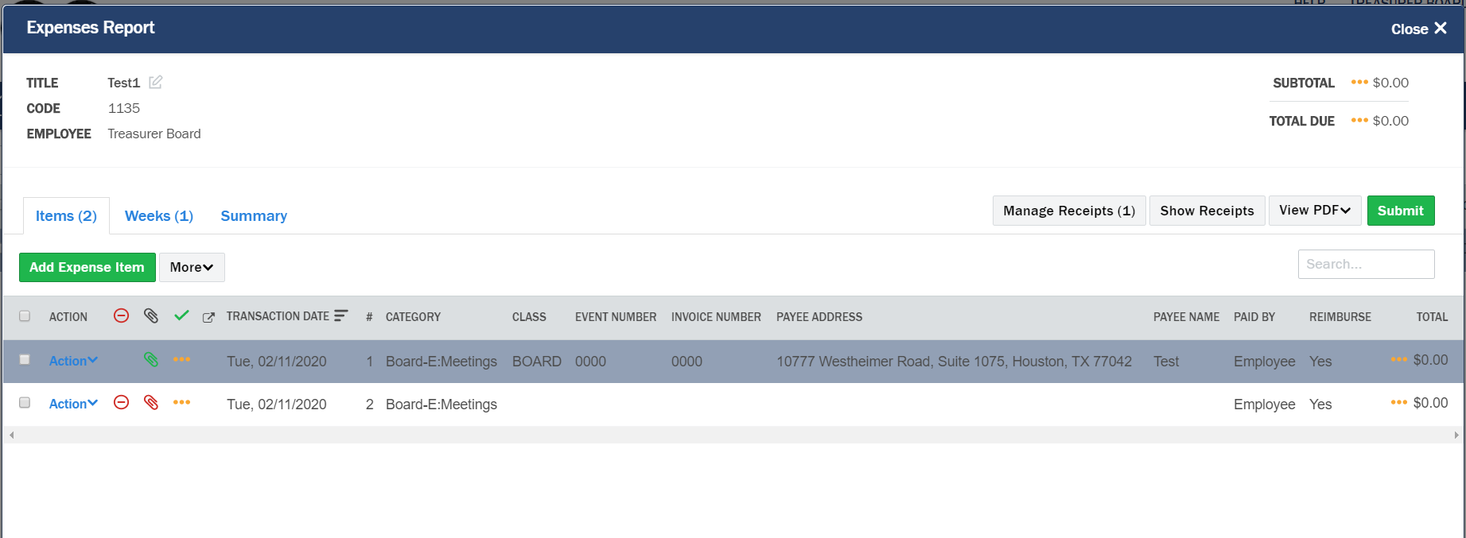

Check Report Status
- From the Nexonia Expenses page, view the Paid and Paid Date columns. These fields are updated when checks are issued for the report.
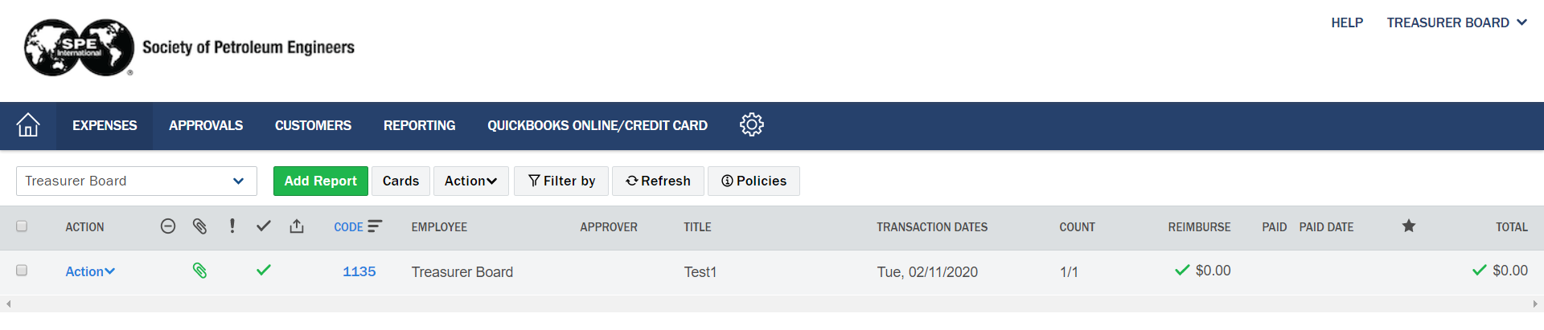

Duplicate a Report
- From the Nexonia Expenses page, select the appropriate Report. Click on Action to display the list of additional functions.
