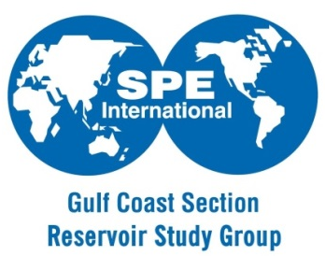
SPE Gulf Coast Section - Reservoir Study Group Sponsorship Opportunities
Reservoir Technology Symposium

Who Are We?
Our purpose is to serve as a forum for Petroleum Engineers and Geoscientists to network and disseminate the knowledge and technology needed to achieve the many objectives of Reservoir Management, including understanding risk, increasing production and reserves, and maximizing recovery.
What is the Reservoir Technology Symposium?
The Reservoir Technology Symposium is an annual event hosted by the SPE Gulf Coast Section Reservoir Study Group since 2010. Our main objective is to provide attendees with an opportunity to learn and discuss, with highly recognized speakers, the latest and trending reservoir management topics as well as sharing top technology development.
Strength in Number:
Having started just in 2010, the Reservoir Technology Symposium has been year after year growing in popularity and quickly adapting to better serve our technical community needs. During past 2 years, symposium has had an average of 160 attendees.
Interested in Sponsorship?
For more information about the Reservoir Study Group and our upcoming events, please visit our website, http://www.spegcs.org/study-groups/reservoir. If you would like to sponsor, please contact Eric Laine (SPE@ericlaine.com) and Alejandro Lerza (alerza@chevron.com). We are a non-profit organization 501c3 (tax exempt).
What does SPE do with our generous sponsor’s donations?
Funds donated to the Society of Petroleum Engineers – Gulf Coast Section become college scholarships for students whose families live within GCS’ boundary. If you would like to know more about it, http://www.spegcs.org/spegcs-scholarship-fund

 | Benefits to Being a Reservoir  Symposium Sponsor | PLATINUM | GOLD | SILVER | BRONZE
 |  | $5,000 | $3,000 | $1,500 | $1,000
Sponsor recognition at symposium and in all media related events  (i.e. LinkedIn, Twitter, Instagram, etc.) |  | Y | Y | Y | Y
Logo recognition on SPE-GCS Reservoir Study Group website |  | Y | Y | Y | Y
Sponsor logo recognition on programs brochure |  | Y | Y | Y | Y
 | Photobooth display logo  (see picture 6) | Y | Y | Y | Y
 | Sponsor banner display | Y | Y | Y | -
 | Number of table(s) per sponsor  (see picture 4 and 5) | 2 | 1 | - | -
 | Introduction to symposium speaker | Y | Y | - | -
 | Sponsor logo recognition at breakfast and lunch table | Y | - | - | -
 | Free registration passes for company representatives | 3 | 2 | 1 | -
 | Sponsor’s logo on notepad, pen, pencil, cup, koozie, etc. on attendee tables | Y | Y | - | -
 | Student poster session award prizes offered in name of your company (s) | - | - | - | Y
 | Sponsor logo/name recognition on student attendee(s) badges | - | - | - | Y

Day 2 Training

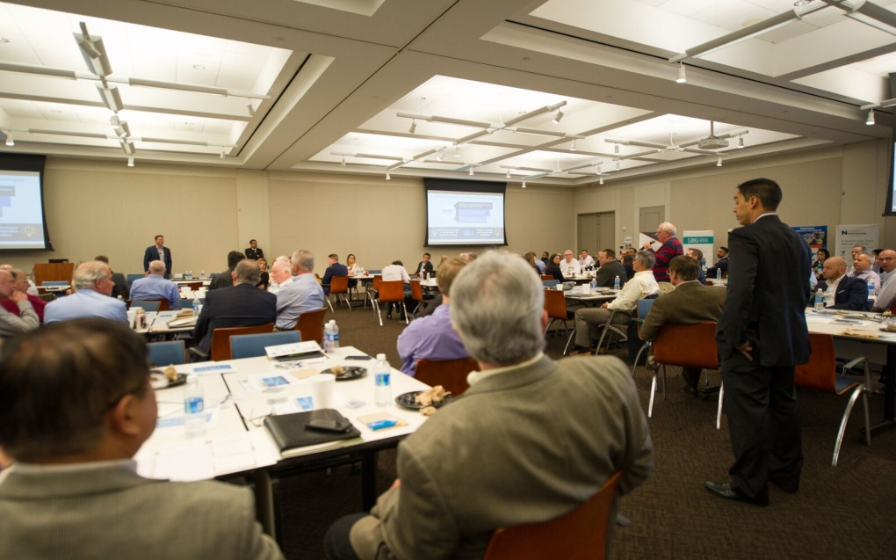

Figure 1 - 2017 Reservoir Technology Forum – Presentations

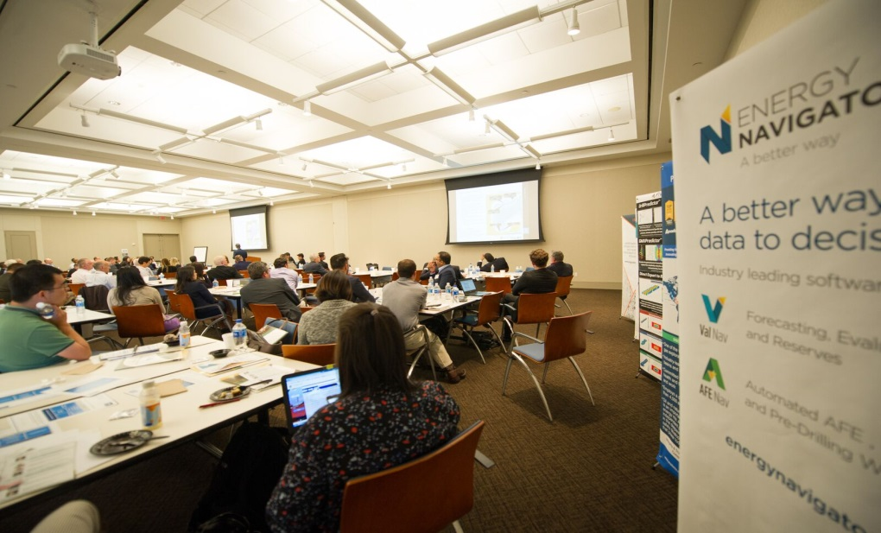

Figure 2 - 2017 Reservoir Technology Forum – Presentations

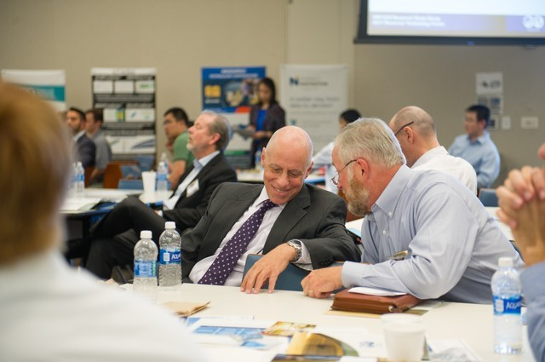
Figure 3 - 2017 Reservoir Technology Forum Discussions

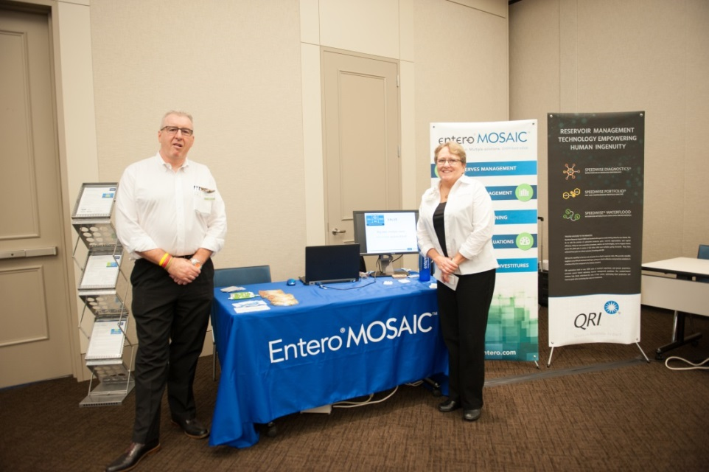

Figure 4 - 2017 Reservoir Technology Forum – Sponsors table and setup

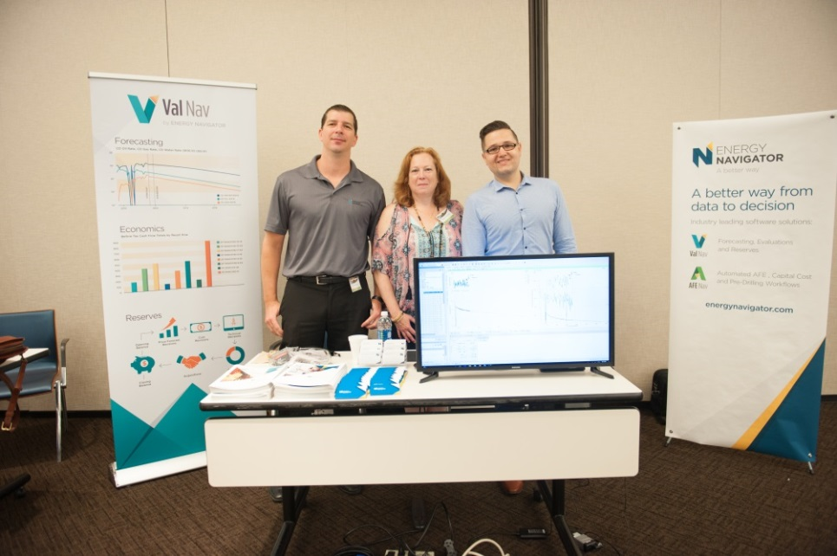

Figure 5 - Reservoir Technology Forum – Sponsors table and setup

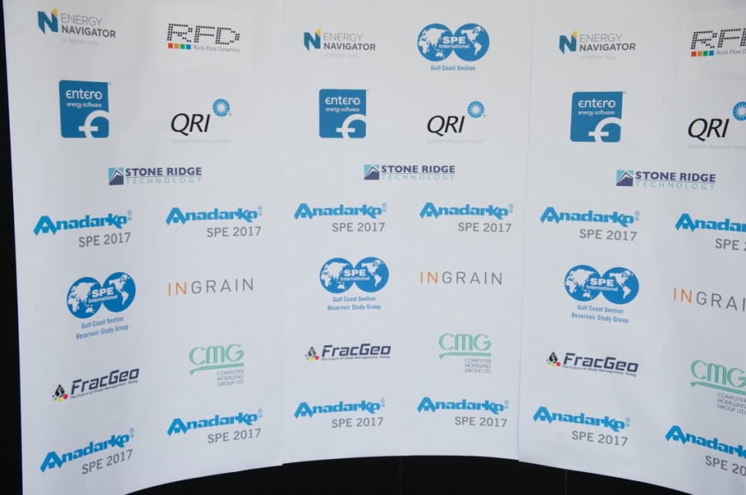

Figure 6 - Reservoir Technology Forum – Photobooth display
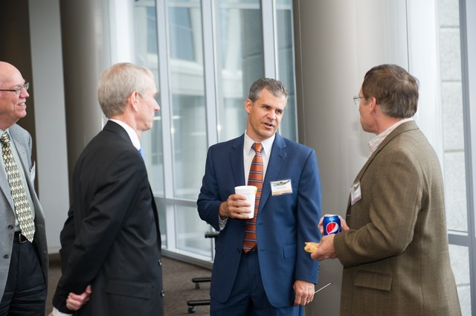

Figure 7 - 2017 Reservoir Technology Forum – Networking

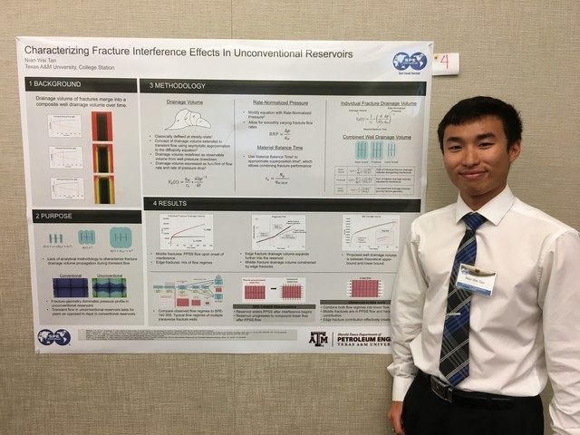

Figure 8 - 2017 Reservoir Technology Forum – Student Poster Contest

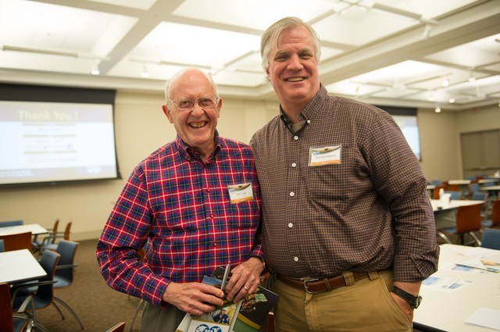

Figure 9 - 2017 Reservoir Technology Forum – Speakers on break

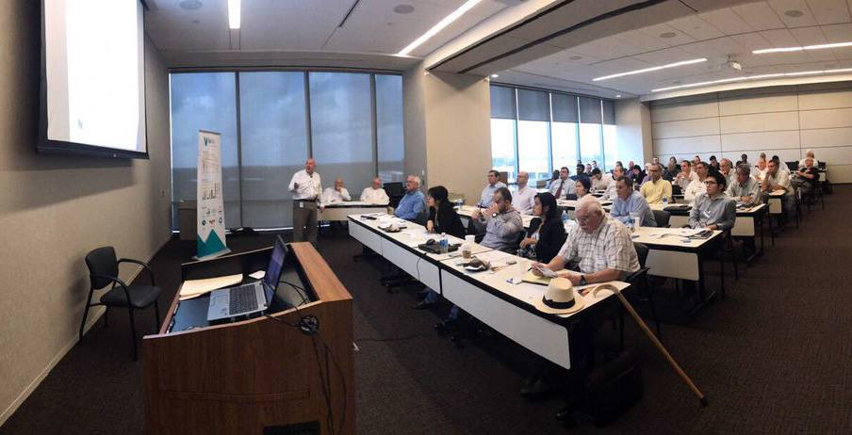
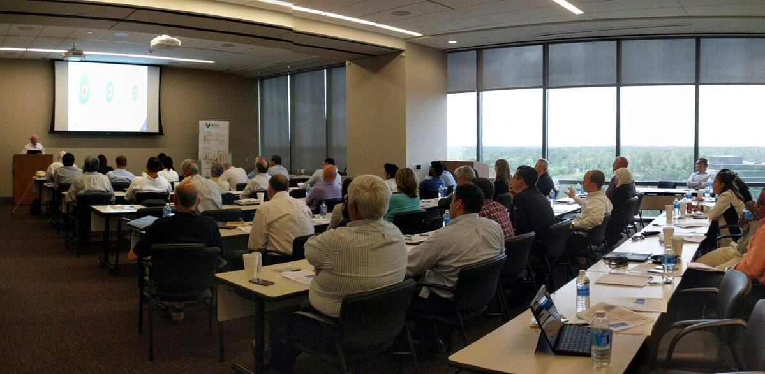
Figure 11 - 2017 Reservoir Technology Forum - Technical Training (Day 2)
Figure 10 - 2017 Reservoir Technology Forum - Technical Training (Day 2)

