Houston Texans Grille
Directions & Parking Map
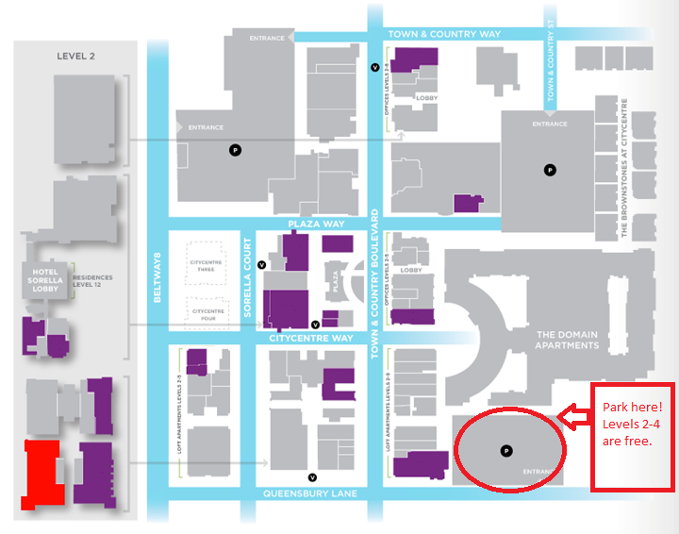
12848 Queensbury Lane * Houston, TX 77024
From I-10 West
- Take Exit 756A towards Texas 8 S/Texas 8 N/Frontage
- Merge onto I-10 Frontage Rd. West
- U-Turn under I-10 to Frontage Rd. East
- Take sharp right onto Town & Country Blvd.
- Take first right onto Town & Country Lane/Town & Country Blvd.
- Take a right on Queensbury Lane – Houston Texans Grill will be on your right (2nd level) *Valet
OR Take a left on Queensbury Lane for Parking Garage on your left

From Beltway 8/Sam Houston Tollway North
- Take exit toward Memorial/Kimberly Ln
- Pass through two stoplights and shopping center – Town and Country
- Take a Right onto Queensbury Lane
- Houston Texans Grille will be on your left (2nd Level) *Valet
OR Continue straight on Queensbury – through Stop Sign – Parking Garage will be on your left

