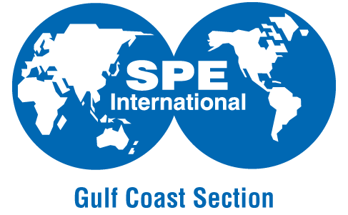
February 10th, 2015 SPE Executive Breakfast Agenda
Houstonian Hotel – Juniper Room
Time | Speaker | Topic | Objective
6:45 -7:30 AM | Registration | Registration | Orientation, Networking & Coffee
7:30 – 7:55 AM | Jeanne Perdue, SPE-GCS Chair | Safety Moment and SPE-GCS “State of the Union” | A case for 2015 increased support, voluntarism. “How SPE-GCS can help you in low oil price scenarios”
7:55-8:30 AM | Ganesh Thakur, Helge Hove Haldorsen, Nathan Meehan | Panel of Past, Present, and Future SPE Presidents | Panel speaks about the historical & future importance of SPE in the Industry. Q&A.
8:30-8:45 AM | Break | Break | Networking & Coffee
8:45-9:20 AM | Rustom Mody, VP Technology Baker Hughes | One Degree of Separation: SPE’s Pivotal Role in Keeping the Wheels of Innovation Turning During $50 oil | Baker Hughes, top supporter of SPE in 2014.  Keynote Speech and Q&A.
9:20 – 9:40 AM | SPE Leadership Team | Committee Table Tour with Executives | “SPE-edy” Breakout sessions. 2015 initiatives for Education, Technical, Special Events
9:40 – 9:50 AM | SPE Leadership Team | Facilitated Session at the Tables | Executives provide their input on the future of SPE-GCS
9:50 – 10:00 AM | Jeanne Perdue, SPE-GCS Chair | Closing Remarks & Next Steps for SPE-GCS | Conclude session
10:00-10:30 AM | Coffee Break | Photos, Networking & Coffee | Photos, Networking & Coffee

